Can you make Pi?

This problem is inspired by the following picture.

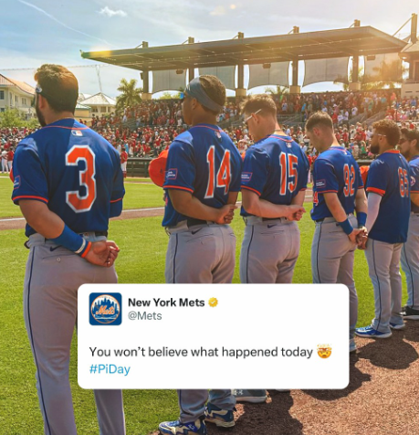You have been given the completed Player class which stores the Player’s uniform number (getNumber()) and name (getName()). (It turns out the Player’s name is not relevant in this problem, but I did not realize that fact until I completed this program, and I have no desire to go back and change the problem)

You may assume players numbered 0-9 are listed as a single digit (e.g. the player in the picture is 3, not 03.)

You have been given the completed TeamLineup class which stores the target number and an ArrayList of all available Players.

You are to complete the static method getlineup in the CanYouMakePi class. The method has a single TeamLineup object as its only parameter. This method will return the longest String possible that matches the beginning of the String target in the parameter in the TeamLineup constructor.

The Player class

public class Player {

private int num;

private String name;

// Constructor for objects of class Player

public Player(int n, String s) {

num = n;

name = s;

}

/**

* @return the Player’s uniform number

*/

public int getNumber() { return num; }

/**

* @return the name of the Player

*/

public String getName() { return name; }

public int hashCode() {

return new Integer(getNumber()).hashCode() + getName().hashCode();

}

public boolean equals(Object obj) {

Player p = (Player) obj;

return getNumber() == p.getNumber() && getName().equals(p.getName());

}

}

The TeamLineup class

public class TeamLineup

{

private String teamTarget;

private ArrayList<Player> team;

// Constructor for objects of class TeamLineup

public TeamLineup(String target, ArrayList<Player> players) {

teamTarget = target;

team = players;

}

public String getTarget() { return teamTarget; }

public ArrayList<Player> getTeam() { return team; }

public boolean equals(Object obj) {

TeamLineup tmp = (TeamLineup) obj;

return getTarget() == tmp.getTarget() && getTeam().equals(tmp.getTeam());

}

}

You are to complete the static method getlineup in the CanYouMakePi class. This method will uses the Player numbers from the Player Objects stored the ArrayList in the TeamLineup Object to create the longest String possible that matches the beginning of the String target from the TeamLineup Object.

The following code shows the results of the getLineUp method.

|  |  |
| --- | --- |
| The following code | Returns |
| ArrayList<Player> team = new ArrayList<Player>();  team.add( new Player(3, "player 1"));  team.add( new Player(14, "player 12"));  team.add( new Player(5, "player 13"));  TeamLineup t = new TeamLineup("314159265", team); |  |
| CanYouMakePi.getLineUp(t); | "314" |
| team.add( 0, new Player(9, "player 15"));  team.add( new Player(65, "player 16"));  team.add( new Player(15, "player 17"));  t = new TeamLineup("314159265", team); |  |
| CanYouMakePi.getLineUp(t); | "314159" |
| team.add(2, new Player(2, "player 18"));  t = new TeamLineup("314159265", team); |  |
| CanYouMakePi.getLineUp(t); | "314159265" |
| team.add(2, new Player(3, "player 183"));  t = new TeamLineup("314159265358979", team); |  |
| CanYouMakePi.getLineUp(t); | “31415926535” |

Note: This class can be used to match any number as demonstrated in the example on the following page.

The following code shows the results of the getLineUp method.

|  |  |
| --- | --- |
| The following code | Returns |
| ArrayList<Player> team = new ArrayList<Player>();  team.add( new Player(10, "p1"));  team.add( new Player(3, "p2"));  team.add( new Player(5, "p3"));  team.add( new Player(0, "p4"));  team.add( new Player(6, "p5"));  team.add( new Player(1, "p6"));  t = new TeamLineup("6018", team); |  |
| CanYouMakePi.getLineUp(t); | "601" |

this page intentionally left blank